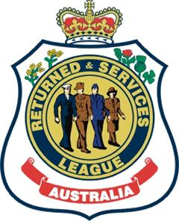
RSL Woden Valley sub-branch

cordially invites members and guests to the ANNUAL ANZAC Eve dinner
Monday 24 April 6pm for 6.30pm; $42
Orion Room, Southern Cross Club, Corinna Street Woden ACT
Our speaker at this year’s dinner is the new CEO of RSL National, Georgie Macris. The topic of Georgie’s address will be A young girl’s reflections on ANZAC Day, and will bring into context the genesis of her compelling need to become involved in some way in championing Australia’s veteran community.

Mains: A choice of Roasted Chicken Supreme or Slow Roasted Sirloin; Dessert: Choice of Chocolate Marquise (GF) or Warm Apple Strudel. Wines and orange juice will be available on each table and there is a limited dry till for beer. Cash bar is available for extra/other drinks.

Options for payment:
Please RSVP with credit card details and any dietary restrictions by April 20 to events@rslwoden.org.au.

Book and advise dietary restrictions before mailing cheque payments to PO Box 415, Woden 2606.

If you book and pay by direct credit (EFT) to RSL Money BSB 642-170 Account 751928 then please don’t forget to add your name to the payment and let us have any dietary restrictions.

